 | Michigan Cup Memorial Classic Race  2022 Registration Form  10 AM Sunday, February 5, 2023  Forbush Corner, Frederic, MI | 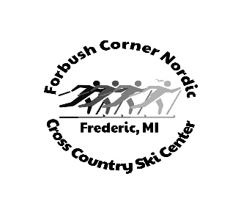

Fees: $35.00 Seniors______ $15.00 Juniors______
($10 goes to the Ulby and Bad Axe Cross Country teams in memory of Larry Kanaby)
10 km- Interval group start

First Name | _____________________________ Last Name ____________________________
Address | _____________________________________________________________________
City | ____________________________ State ________ Zip ___________________
Country | ____________________________ Phone ________________________________
Email | _____________________________________________________________________
Birthdate | _____________________________ Age _______ Team ____________________
Sex M F

Pre-registration only through Skireg or through the shop prior to race day.
Mail in registration should be sent to:
PO Box 118
Gaylord, Mi 49734
Please make checks payable to Forbush Corner Nordic

